Square Rotunda
# Source: AI Source: Provided by: [Data Path: Persons Table -> ID Column: 1, Name_En Column: Motasem Essam] -> From: [ChatGPT] on [7/25/2026]
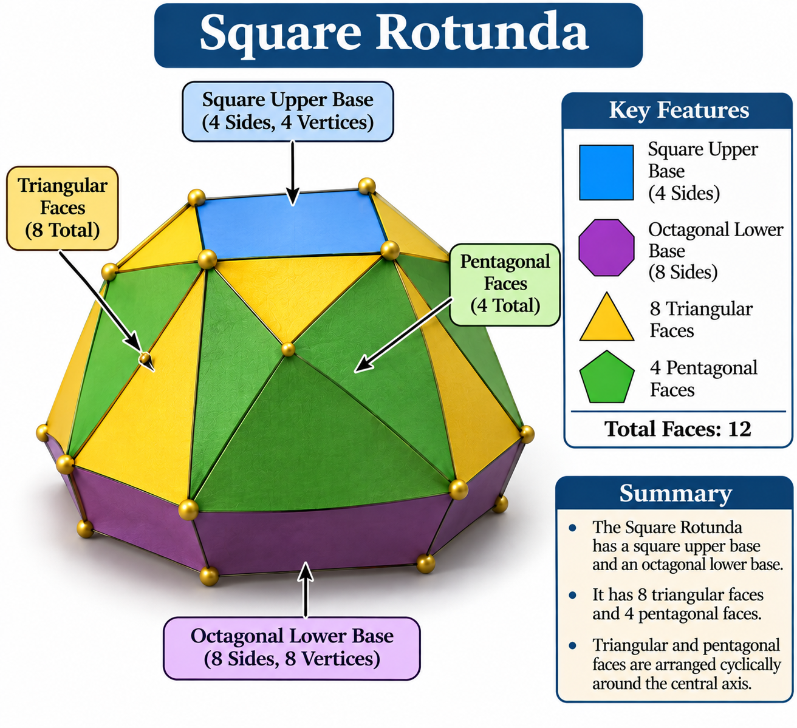

Definition
# Source: AI Source: Provided by: [Data Path: Persons Table -> ID Column: 1, Name_En Column: Motasem Essam] -> From: [ChatGPT] on [7/25/2026]
A Square Rotunda is a member of the Rotunda family of polyhedra, characterized by a square upper base, an octagonal lower base, and a cyclic arrangement of triangular and pentagonal lateral faces.
It follows the general rotunda construction, in which an $n$-sided polygon is connected to a parallel $2n$-sided polygon through triangular and pentagonal faces.
Unlike the Pentagonal Rotunda (J6), the Square Rotunda is not one of the 92 convex Johnson solids. Its pentagonal lateral faces may need to be geometrically distorted to form the solid. <Cite refs={["turn251677search21","turn251677search3"]}/>

Geometric Structure
# Source: AI Source: Provided by: [Data Path: Persons Table -> ID Column: 1, Name_En Column: Motasem Essam] -> From: [ChatGPT] on [7/25/2026]
The Square Rotunda consists of:
- Upper Base: A square polygon with four sides and four vertices.
- Lower Base: An octagonal polygon with eight sides and eight vertices.
- Triangular Faces: Eight triangular lateral faces.
- Pentagonal Faces: Four pentagonal lateral faces.
- Alternating Arrangement: Triangular and pentagonal faces are arranged cyclically around the central axis.
<Cite refs={["turn251677search21","turn251677search3"]}/>

Face Composition
# Source: AI Source: Provided by: [Data Path: Persons Table -> ID Column: 1, Name_En Column: Motasem Essam] -> From: [ChatGPT] on [7/25/2026]
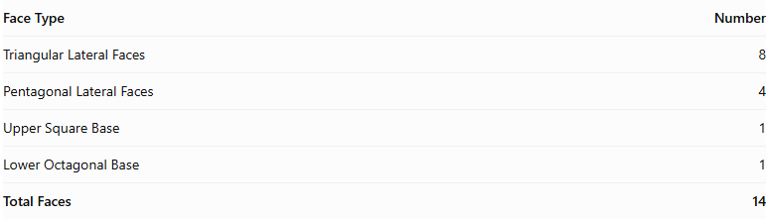
Face Type | Number
Triangular Lateral Faces | 8
Pentagonal Lateral Faces | 4
Upper Square Base | 1
Lower Octagonal Base | 1
Total Faces | 14
The eight triangular faces and four pentagonal faces form the lateral structure connecting the square and octagonal bases.

Mathematical Properties
# Source: AI Source: Provided by: [Data Path: Persons Table -> ID Column: 1, Name_En Column: Motasem Essam] -> From: [ChatGPT] on [7/25/2026]
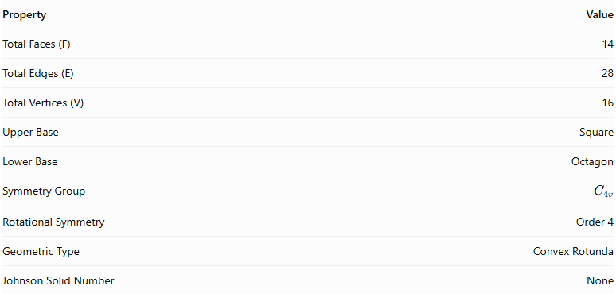
Property | Value
Total Faces (F) | 14
Total Edges (E) | 28
Total Vertices (V) | 16
Upper Base | Square
Lower Base | Octagon
Symmetry Group | $$C_{4v}$$
Rotational Symmetry | Order 4
Geometric Type | Convex Rotunda
Johnson Solid Number | None
General Rotunda Formulas:
For an $n$-gonal Rotunda:
$$F=3n+2, E=7n, V=4n$$
For the Square Rotunda, $n=4$:
$$F=14, E=28, V=16$$
Euler's Polyhedron Formula:
$$V-E+F=2$$
$$16-28+14=2$$
<Cite refs={["turn251677search21","turn251677search3"]}/>

Geometric Characteristics
# Source: AI Source: Provided by: [Data Path: Persons Table -> ID Column: 1, Name_En Column: Motasem Essam] -> From: [ChatGPT] on [7/25/2026]
- Square Upper Base: Its upper base consists of four sides and four vertices.
- Octagonal Lower Base: Its lower base consists of eight sides and eight vertices.
- Alternating Lateral Faces: Eight triangular faces and four pentagonal faces form the lateral structure.
- Fourfold Rotational Symmetry: Its arrangement repeats after a rotation of ${90}^{∘}$.
- Cyclic Arrangement: Its lateral faces are arranged around a central axis.
- Rotunda Construction: It follows the general rotunda arrangement of triangular and pentagonal lateral faces.
- Johnson Solid Relationship: Unlike the Pentagonal Rotunda (J6), the Square Rotunda is not a Johnson solid because it cannot be constructed with all the required faces regular and all edges equal.

Construction of Square Rotunda

Geometric Instruments Used
# Source: AI Source: Provided by: [Data Path: Persons Table -> ID Column: 1, Name_En Column: Motasem Essam] -> From: [ChatGPT] on [7/25/2026]
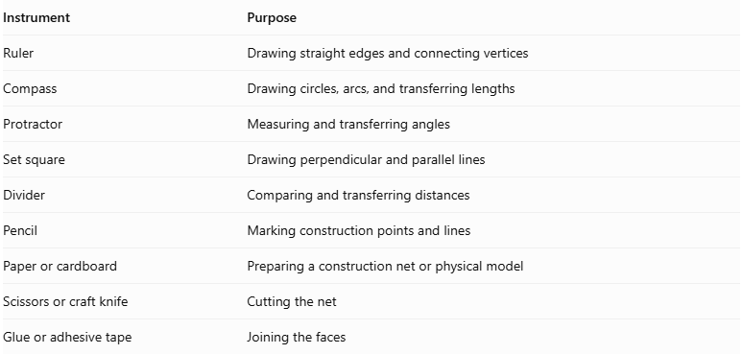
Instrument | Purpose
Ruler | Drawing straight edges and connecting vertices
Compass | Drawing circles, arcs, and transferring lengths
Protractor | Measuring and transferring angles
Set square | Drawing perpendicular and parallel lines
Divider | Comparing and transferring distances
Pencil | Marking construction points and lines
Paper or cardboard | Preparing a construction net or physical model
Scissors or craft knife | Cutting the net
Glue or adhesive tape | Joining the faces

Instrument-Based Construction Procedures
# Source: AI Source: Provided by: [Data Path: Persons Table -> ID Column: 1, Name_En Column: Motasem Essam] -> From: [ChatGPT] on [7/25/2026]
No coordinate-based construction
The construction uses geometric instruments, polygon geometry, measured lengths, angles, and edge matching. It does not use coordinate axes, coordinate points, or coordinate equations.

Construct the Upper Square Base
# Source: AI Source: Provided by: [Data Path: Persons Table -> ID Column: 1, Name_En Column: Motasem Essam] -> From: [ChatGPT] on [7/25/2026]
- Draw a straight line segment using a ruler.
- Construct a perpendicular line at one endpoint using a compass and ruler.
- Set the compass to the required side length.
- Mark the remaining vertices so that all four sides are equal.
- Join the four vertices to complete the square.
- Label the vertices $A$, $B$, $C$, and $D$.

Construct the Lower Octagonal Base
# Source: AI Source: Provided by: [Data Path: Persons Table -> ID Column: 1, Name_En Column: Motasem Essam] -> From: [ChatGPT] on [7/25/2026]
- Draw a circle using a compass.
- Construct two perpendicular diameters through its center.
- Bisect the four central right angles to obtain eight equally spaced points on the circumference.
- Join consecutive points using a ruler.
- Verify that the resulting regular octagon has eight equal sides.
- Label the vertices $E_{1},E_{2},…,E_{8}$.

Construct the Eight Triangular Lateral Faces
# Source: AI Source: Provided by: [Data Path: Persons Table -> ID Column: 1, Name_En Column: Motasem Essam] -> From: [ChatGPT] on [7/25/2026]
- Prepare eight triangular faces using a ruler, compass, and protractor.
- Determine their dimensions from the selected Square Rotunda model.
- Arrange them in the required alternating lateral pattern.
- Match their edges to the corresponding edges of the bases and pentagonal faces.
- Check that every triangle fits its neighboring faces without gaps or unintended overlaps.

Construct the Four Pentagonal Lateral Faces
# Source: AI Source: Provided by: [Data Path: Persons Table -> ID Column: 1, Name_En Column: Motasem Essam] -> From: [ChatGPT] on [7/25/2026]
- Prepare four pentagonal faces.
- Determine the side lengths and interior angles required by the selected model.
- Arrange the pentagons alternately among the triangular lateral faces.
- Match each pentagon's edges with the appropriate neighboring triangles.
- Verify that the pentagons close the lateral structure correctly.

Arrange the Faces
# Source: AI Source: Provided by: [Data Path: Persons Table -> ID Column: 1, Name_En Column: Motasem Essam] -> From: [ChatGPT] on [7/25/2026]
- Position the square and octagonal bases parallel to each other.
- Place the eight triangles and four pentagons between the two bases.
- Check the edge lengths at every shared boundary.
- Verify the intended fourfold symmetry.
- Confirm that the arrangement forms a closed surface without unmatched edges.

Assemble the Solid
# Source: AI Source: Provided by: [Data Path: Persons Table -> ID Column: 1, Name_En Column: Motasem Essam] -> From: [ChatGPT] on [7/25/2026]
- Draw or prepare a net using the verified face arrangement.
- Add suitable tabs if the model will be assembled from paper or cardboard.
- Cut out the faces.
- Fold the connecting edges where necessary.
- Join the matching edges carefully.
- Attach the square and octagonal bases.
- Inspect the assembled solid from different directions.
Construction accuracy: The four pentagons must have dimensions and angles compatible with the triangles and both bases. Using four ordinary regular pentagons, eight equilateral triangles, a regular square, and a regular octagon with one common edge length does not automatically produce a valid closed Square Rotunda. The geometry must be adjusted and verified before assembly.

Key Points
# Source: AI Source: Provided by: [Data Path: Persons Table -> ID Column: 1, Name_En Column: Motasem Essam] -> From: [ChatGPT] on [7/25/2026]
- Upper Base: Square.
- Lower Base: Octagon.
- Triangular Lateral Faces: 8.
- Pentagonal Lateral Faces: 4.
- Total Faces: 14.
- Total Edges: 28.
- Total Vertices: 16.
- Rotational Symmetry: Order 4.
- Classification: Generalized Rotunda.
- Johnson Solid: Not a Johnson solid.

Main Classification
# Source: AI Source: Provided by: [Data Path: Persons Table -> ID Column: 1, Name_En Column: Motasem Essam] -> From: [ChatGPT] on [7/25/2026]
Solid Geometry
└── Types of Solids
└── Rotunda
└── Types of Rotundas
└── Square Rotunda

Conclusion
# Source: AI Source: Provided by: [Data Path: Persons Table -> ID Column: 1, Name_En Column: Motasem Essam] -> From: [ChatGPT] on [7/25/2026]
The Square Rotunda is a generalized rotunda characterized by its square upper base, octagonal lower base, and alternating arrangement of eight triangular and four pentagonal lateral faces. It has 14 faces, 28 edges, and 16 vertices, with fourfold rotational symmetry.
Important distinction: The Square Rotunda is different from the Square Cupola. The Square Cupola has triangular and square lateral faces, whereas the Square Rotunda has triangular and pentagonal lateral faces. <Cite refs={["turn251677search21","turn251677search0"]}/>

